PREPARE PYTHON IN ENVIRONMENT
Task1: download set up of python by using google and Microsoft adge
Task2: after download set up of python find the version of python
Task3: then start install python set up
Task4: follow instruction of screen
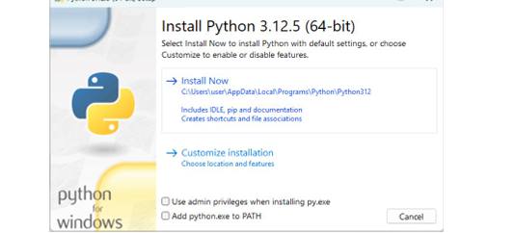
.select both first and second option below the customize installation
.then after click next to complete the installation process of python
.wait for the installation to complete
.after the installation is completed click finish to finish set up process
.verify the installation
.open command prompt
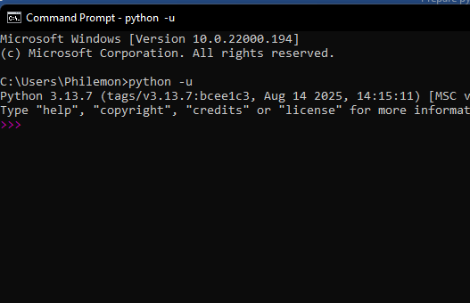
.or terminal window
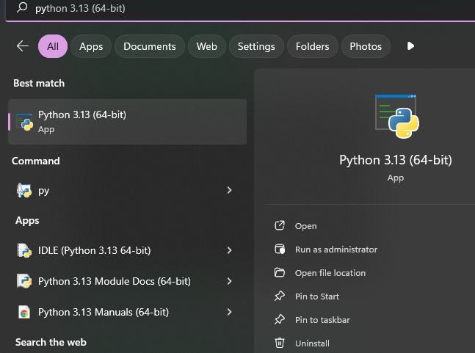
.type python version and press enter
.set up was successful
.example of the python program to make the addition and substation of the two number

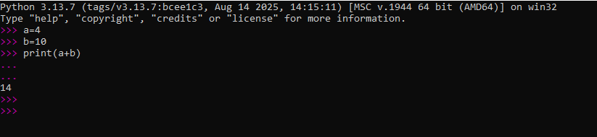

GROUP MEMBERS:
- TUYISHIME ERIC
- MUTUYIMANA ROSINE
- UWASE HIRWA GIKUNDIRO ODILLA

